Waveform preview of ALU WINDOWS EDITION
Brought to you by 3 students

So, the variables are to be seen in the left corner of the images. Every image shows how the result is loaded
Here are said waveforms.

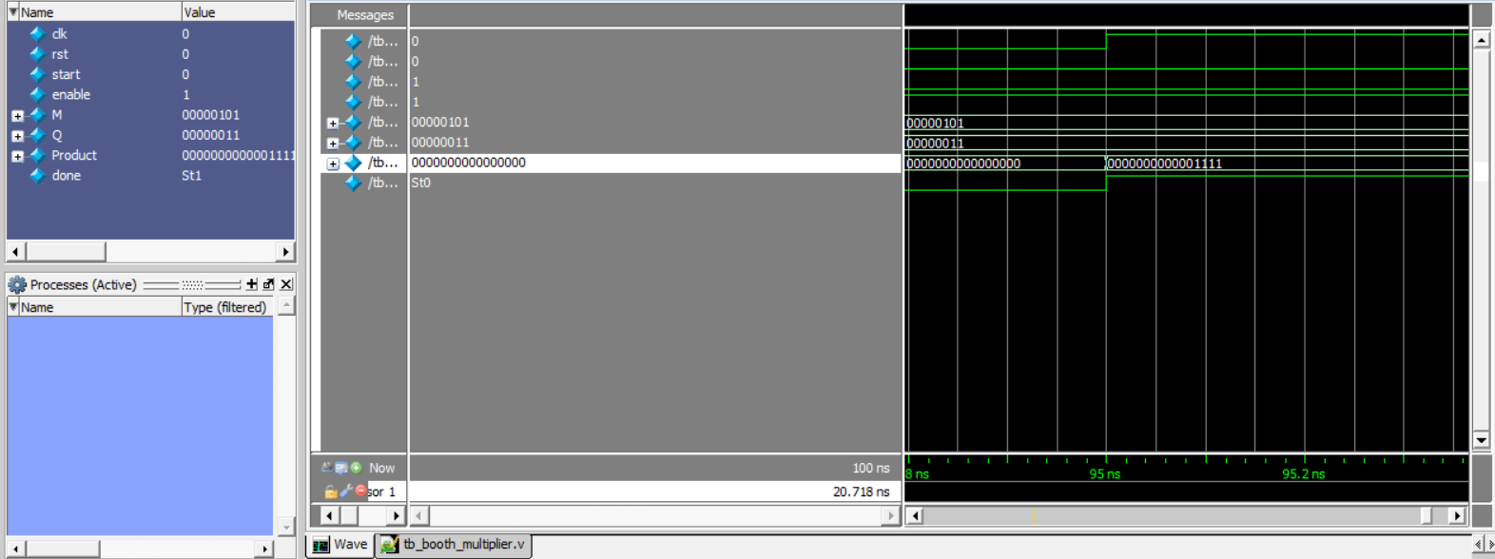
Here you can see the booth multiplier and how it loads the result.

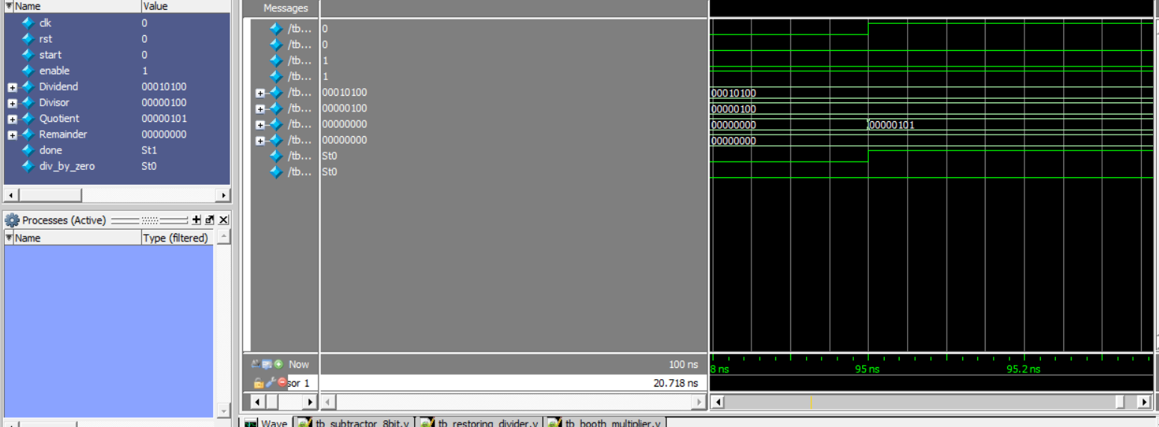
And here is the restoring divider.
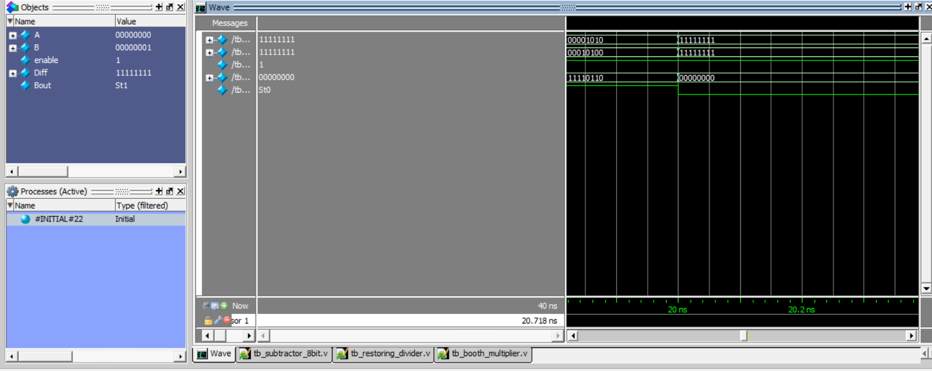

This is the subtractor

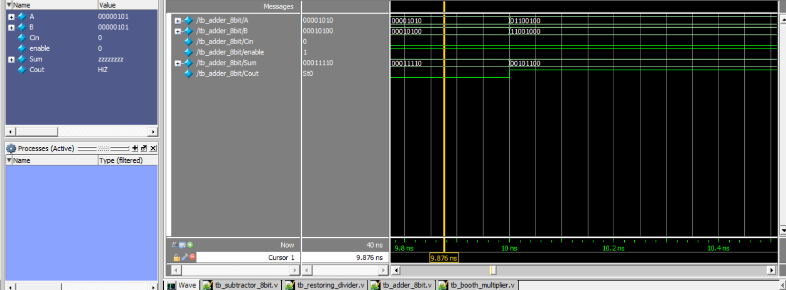

And this is the adder

And now lastly, the waveform for the ALU module:

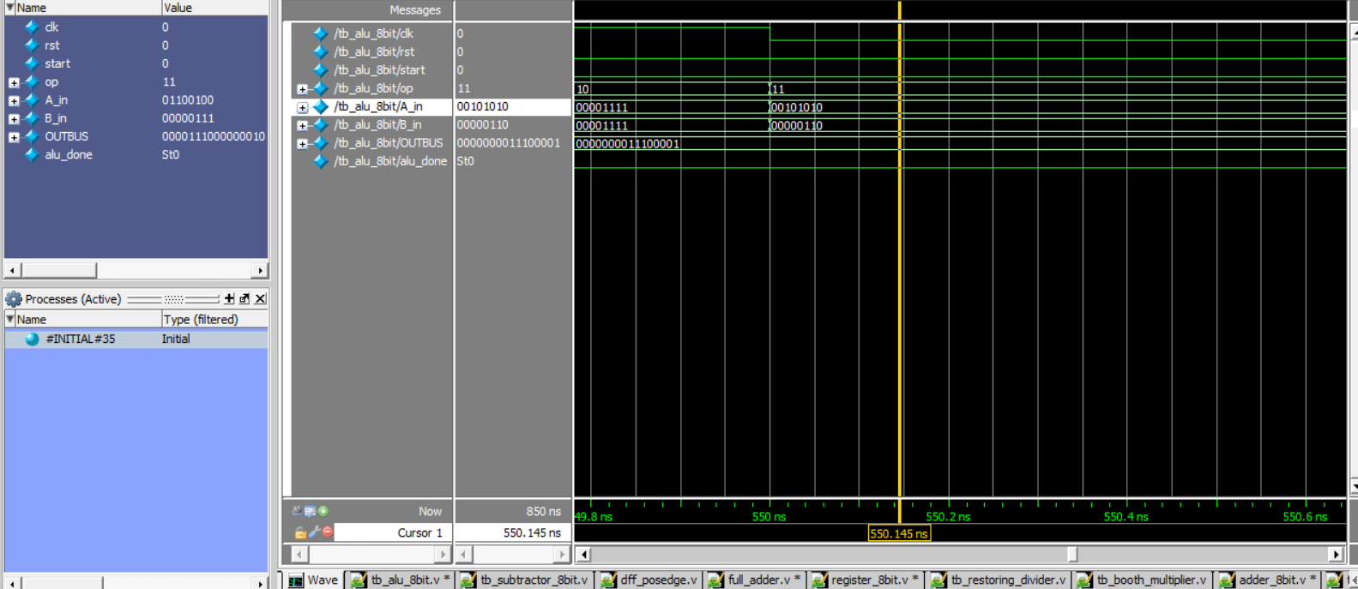

Here, if you squint your eyes a bit, you can see how it loads a new operation (11) which is the division. As it loads the operation, it also loads the registers A and Q with 2 new numbers, one 8 bit number for each.

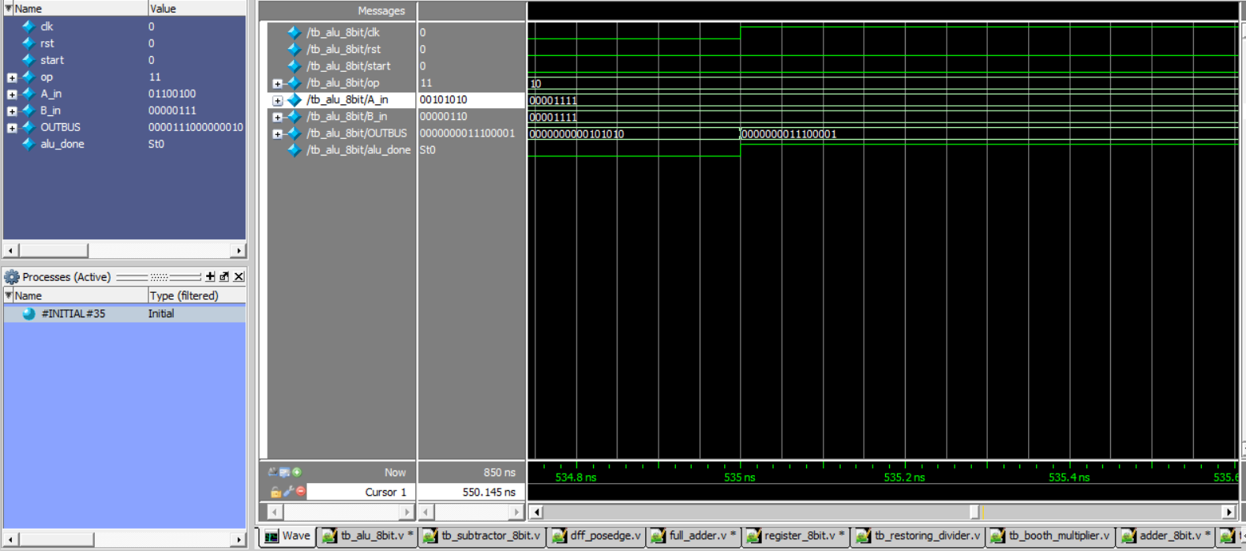
And here you can see it loading the result number into the result register, therefore overwriting the old result.
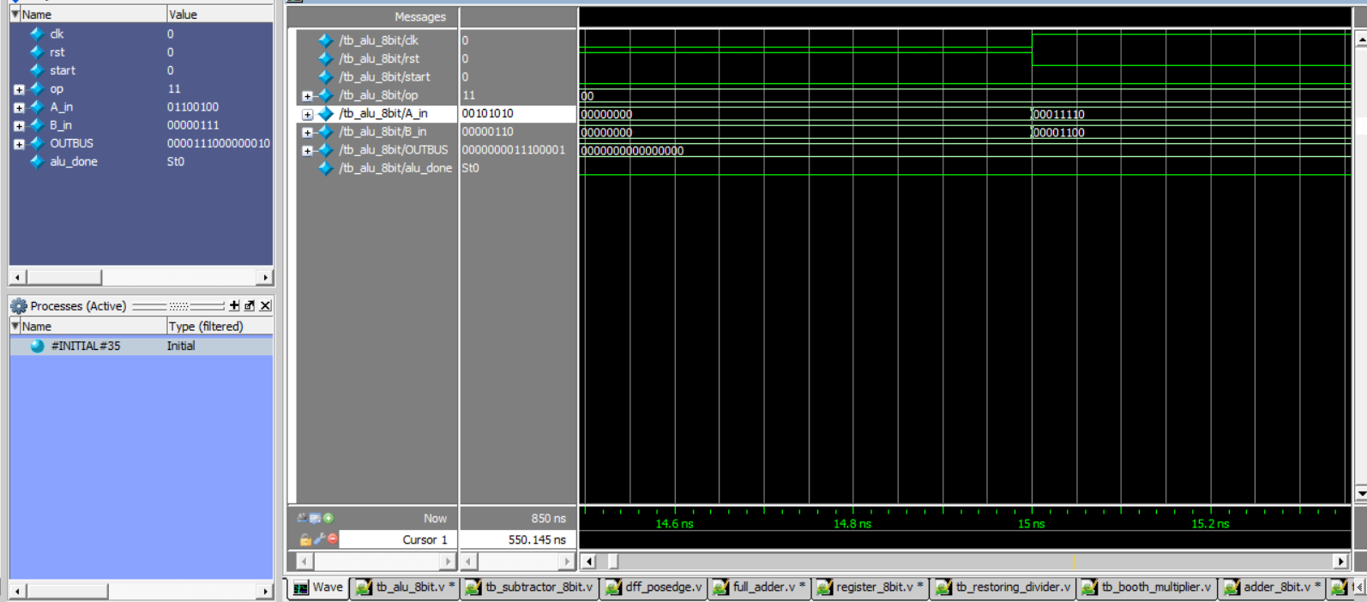

Lastly, you can see the ALU module taking it s first baby steps: loading the first registers.

